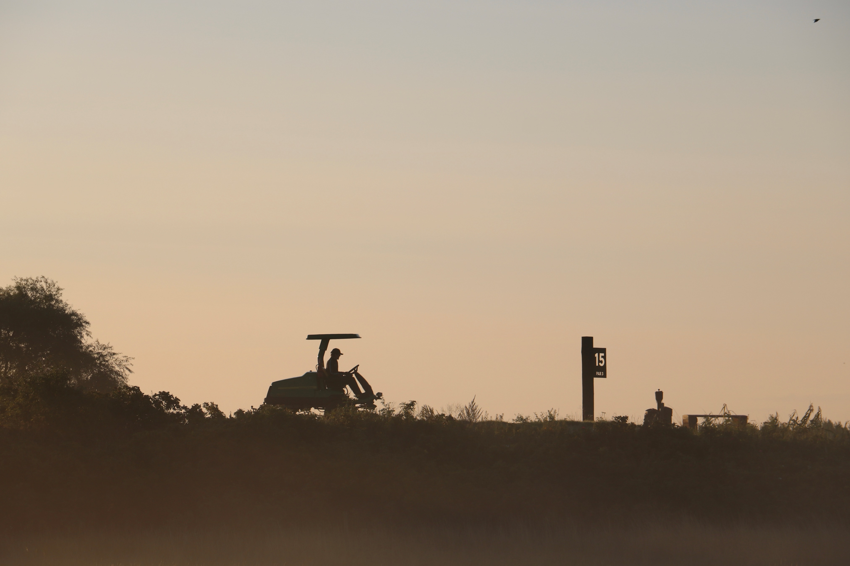
o
Federation of European Golf Greenkeeper Associations
Scholarship Programme
Hosted by Kristianstad’s Golf Club, Sweden
2027

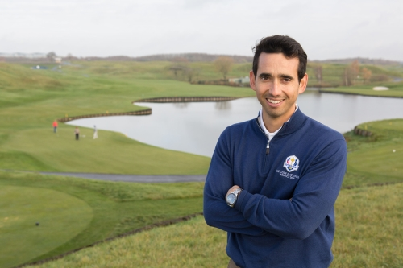
Alejandro Reyes, Course Manager, 2018 & 2023 Ryder Cup Matches, le Golf National, France and Marco Simone, Italy

Foreword
I was born in Spain and studied agronomy at academic level, both in Spain and in England. After that, my objective was to get as much and as varied experience as possible on greenkeeping.
For me, the FEGGA scholarship programme was the best possible opportunity to learn from some of the best professionals in this industry: golf architects, irrigation designers, landscape designers, construction companies, workshop technicians and golf course superintendents from all around the world.
We spent a year working in 4 different high-end golf courses: working hard but improving ourselves every day. It had an enormous impact on my whole career, from the most basic greenkeeping level until today.
As an ex FEGGA scholarship student, I cannot recommend the programme strongly enough.
Thank you, FEGGA.
Alejandro Reyes
Director of Agronomy – TAS
Director of Agronomy – Marco Simone Golf & Country Club

Introduction to the Programme

One major aspect of FEGGA’s work is providing opportunities for aspiring Greenkeepers to help develop and advance their careers. This programme at Kristianstad’s Golf Club provides a unique opportunity combining valuable work experience within a very experienced team led by Bevan Tattersall, coupled with an educational programme touching all aspects of Turf Management. FEGGA are delighted to partner with Kristianstad’s Golf Club in making this exciting programme available to aspiring Greenkeepers throughout Europe.

Do you want a career in Golf Course Management?

Careers in Golf Course Management have become increasingly popular and as a result more education courses have become available to help those individuals develop. The challenge is finding suitable practical Greenkeeping work experience to complement this formal education.

FEGGA in association with Kristianstad’s Golf Club in Sweden have put together what we believe is the perfect opportunity for a greenkeeper to gain practical experience along with a well-structured lecture programme that will have a long-term benefit to any greenkeeper at the end of the 6-month programme.

Based in the idyllic and historic seaside village of Åhus, Kristianstad’s Golf Club is one of the finest golf complexes in Sweden and Europe. Since the club was privately purchased some years ago, major investment has taken place across its 36 holes. The East Course was fully renovated in 2017, a state-of-the-art maintenance facility opened in 2019, resort houses and a sports centre followed in 2020, and the West Course renovation was completed in June 2021. A new Clubhouse opened in 2024, and in 2027 the Club will host an event on the Legends Tour.

Kristianstad’s Golf Club is the fifth-oldest club in Sweden, founded in 1924. The Club prides itself on quality and service and strives to produce the best playing surfaces for its members, guests and tournament golf.

If your CV is lacking in Tournament preparation, this may just be the programme you cannot miss.

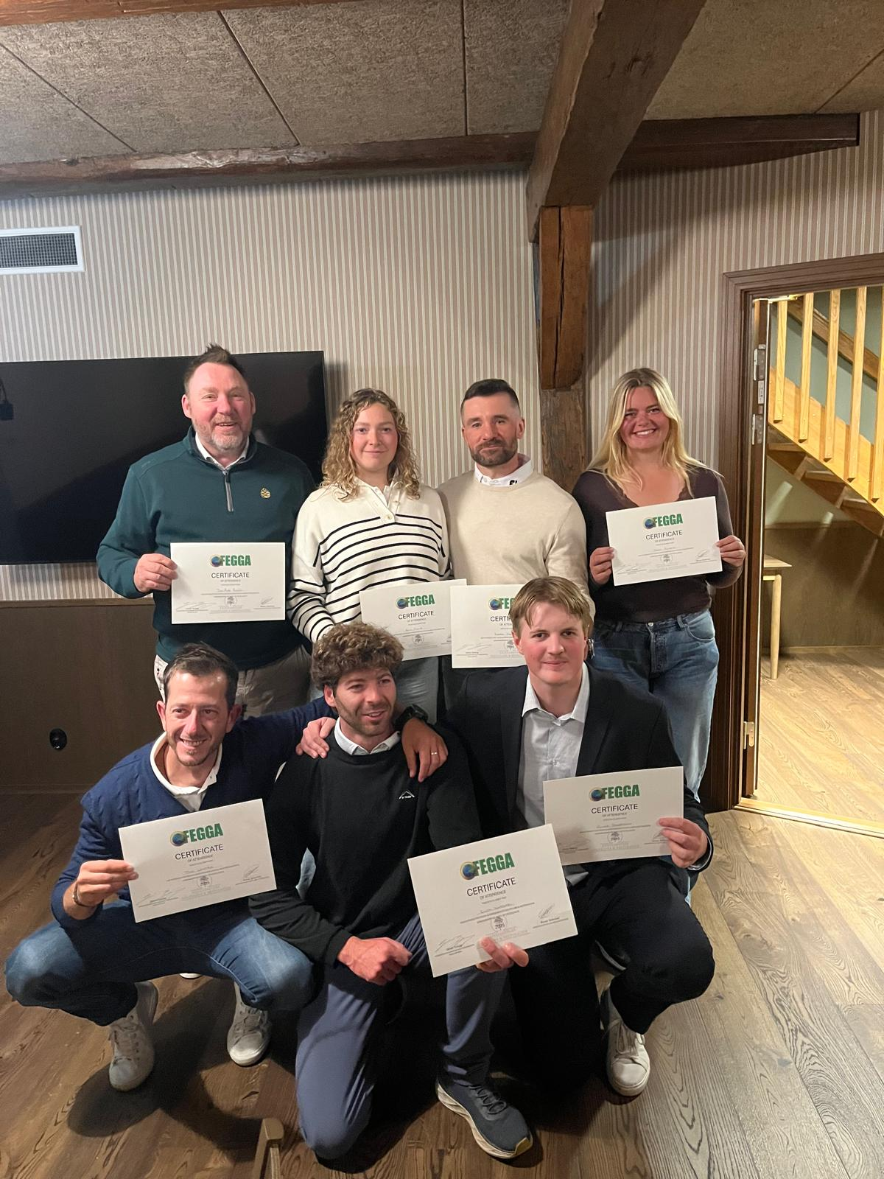

2025 FEGGA Greenkeeping Scholarship Students

A Unique 6-Month Work-Based Experience Scholarship Programme

The Scholarship programme now in its sixth year will be based in Åhus, south of Sweden and located at one of Europe’s premium golf facilities, Kristianstad’s Golf Club.

Each student will gain exceptional work experience at Kristianstad’s GC, working with some of the most qualified people and companies within the industry. The unique experience you will receive blends day to day course management and lecture programmes held weekly throughout the 6 months. This FEGGA programme is the only one of its kind in Europe and covers all aspects of Golf Course management. Throughout this exciting 6 months you will be guided by Kristianstad’s Greenkeeping Management Team, led by Bevan Tattersall.

Programme information

During the 6 months starting on the 5th April 2027, you the student will have a structured programme of lectures which will relate to the work experience you will receive ‘on course’. The type of experience gained during the education programme will be all aspects of Golf Course Management, including - Course Design, Course Maintenance, Agronomy, Grasses, Sustainability, Machinery, Golf Operations, Tournament Management and Tournament Set Up, Budgeting, Health & Safety, Personal Development, to name just a few.

Being part of this programme will also provide other experience opportunities. For example, during 2025 two students were offered the opportunity to work at the 2025 Evian Championship in France. Both Bianca (South Africa) and Rocío (Spain) took the opportunity to work and learn from their two-week experience working alongside Evian's own Greenkeeping team and event officials. Kristian Kouhia (Finland) also had the opportunity to have an eight-day working experience at Marco Simone in the build-up to the 2023 Ryder Cup. In 2024, 2025 and 2026, we also had the opportunity to send one student to work the John Deere Classic, a PGA Tour event, based in Illinois. As part of this unique programme, we will also provide other valuable site visits which will allow you further learning and development opportunities.

The lecture programme will be endorsed by both FEGGA and Kristianstad’s Golf Club and each student will receive a Certificate of Excellence on completion of the programme that concludes on the 5th October 2027.

FEGGA Excellence in Greenkeeper Lecture Programme

- Golf Course Maintenance
- Golf Course Set Up
- Golf Course Design & Construction
- Human Resources
- Soil Biology
- Machinery Maintenance including Grinding
- Machinery Replacement & Planning
- Tournament Management, Set-Up & Experience
- Golf Operations
- Site visits
- Swedish/European Golf
- Project Planning
- Personal Development
- Sustainability

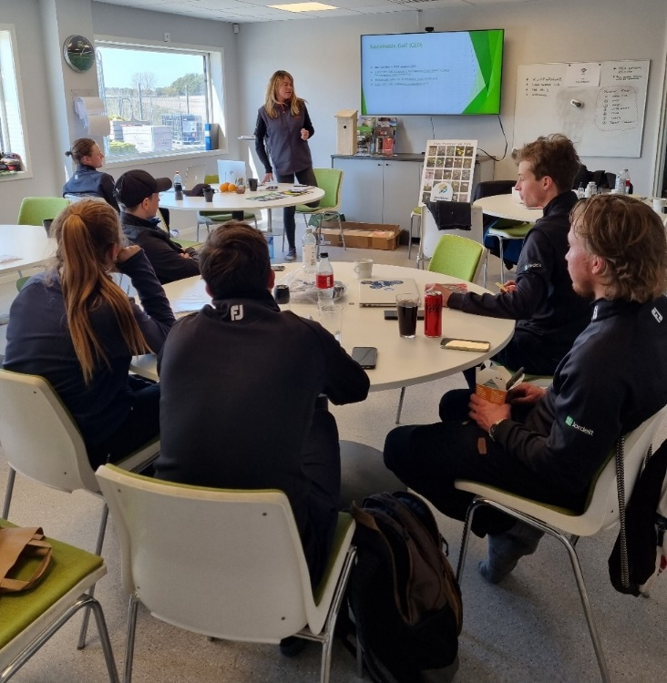

Welcome to Kristianstad’s Golf Club, Åhus, Sweden.
My career to date has spanned over 35 years and I have been fortunate that this fantastic business has enabled me to travel the world, meet some wonderful people and see some of the world’s best Golf Courses.
With experience gained from working and managing over 40 professional tournaments, it is now time for me to pass on this knowledge to the next generation of Turf Managers.
The world of golf is constantly changing. Over the last 30 years, grassed sports surfaces have improved beyond measure, and in golf, we greenkeepers are the driving force behind this.
The position of a Course Manager/Superintendent is vital in making sure standards are always being bettered. Not only for our guest experiences, but also playing surfaces, environment, working environment, health and safety and education.
This education programme, created by FEGGA and hosted at Kristianstad’s Golf Club, aims to help educate and ‘make ready’ the next generation of Golf Course Managers. The training providers will offer a fully comprehensive overview of our profession, all of whom are leaders in your chosen industry.

Bevan Tattersall

There are only 8 places available for the 2027 programme, and each candidate needs to be available from the 5th April 2027 until 5th October 2027.
Applications must be made directly to Bevan Tattersall at Bevan@kristianstadsgk.com Please enclose your CV with your application.
- Each candidate will be paid a rate of 15 euros per hour, based on a 45-hour week, 6 days out of 7. Overtime is available at the same hourly rate.
- Candidates will be contracted on a self-employed basis administered by The Sportsturf Maintenance Company Ltd (STMC), on behalf of FEGGA and Kristianstad’s Golf Club.
- Travel allowance of 150 euros will be provided.
- Housing is provided by Kristianstad’s Golf Club and available at a highly subsidised rate of 250 euros per month. The house is 3.5 km from the Club. A car would be beneficial but not essential.
- Each candidate will have their own bedroom, with use of a communal kitchen, living room, dining room and toilets and showers. You will also enjoy a large garden with wooden decking area with furniture and BBQ.
- All clothing and PPE will be supplied by Kristianstad’s Golf Club.
- Training will be organised by FEGGA and Kristianstad’s Golf Club and conducted during your working week.
- Each candidate MUST be a member of a National Greenkeeper Association that is one of FEGGA’s 23 Member Associations if they are to be considered for the programme.
We look forward to receiving your application.

FEGGA Greenkeeper Scholarship Programme Training Providers

FEGGA
Kristianstad’s Golf Club
The Sportsturf Maintenance Company Ltd
GEO Foundation for Sustainable Golf
John Deere
Husqvarna
Creekhouse
DP World Tour
Mackenzie & Ebert
ICL
Unisport
Malmö Football Club
Turfco/Smithco
Jordelit
Swedish Greenkeepers Association
Swedish Golf Federation
The Foley Company
Symbio
Syngenta
Capillary Flow
Hunter
Rain Bird
DLF Seeds
Barenbrug
Aquatrols
Falsterbo Golf Club
Royal Copenhagen Golf Club
-----------------------------------------------

